**Australian Islamic College 2021**

**ATAR Chemistry Units 3 and 4**

**Task 10 (Weighting: 5%)**

**Esters Validation Test**

Test Time: 45 minutes

Please do not turn this page until instructed to do so.

|  |  |
| --- | --- |
| **First Name** | **Surname** |
|  |  |

|  |
| --- |
| **Teacher** |
|  |

|  |  |
| --- | --- |
| **Mark / 41** | **Percentage** |
|  |  |

Equipment allowed: Pens, pencils, erasers, whiteout, correction tape, rulers and non-programmable calculators permitted by the Schools Curriculum and Standards Authority.

**Special conditions**:

2 marks will be deducted for failing to write your full name on this test paper.

**Teacher help**: Your teacher can only help you during your test in one situation.

If you believe there is a mistake in a question show your teacher and your teacher will tell you if there is a mistake in the question and if appropriate, how to fix that mistake.

**Spelling of Science words** must be correct. Science words with more than one letter wrong (wrong letter and/or wrong place) will be marked wrong.

**Equations** must be written balanced or they will be marked wrong.

Questions must be answered in this booklet.

1. The following list of steps refers to an experimental plan for making an ester in a flask.

Some of the steps in the list are NOT required for this experiment. The steps are NOT in the correct sequence.

1. Heat the mixture under reflux.

2. Add three drops of concentrated sulfuric acid.

3. Add 1 mL of ethanol.

4. Add 1 mL of ethene.

5. Add 1 mL of ethanoic acid.

6. Distil the mixture.

7. Add three drops of phenolphthalein indicator.

Which alternative is the best sequence for making an ester? Circle the correct answer.

(1 mark)

(a) 3, 5, 7, 1

(b) 4, 3, 7, 6

(c) 5, 4, 2, 6

(d) 5, 3, 2, 1

1. Ethyl propanoate is an ester; it is a colorless volatile liquid with a pineapple-like odour. Some fruits such as kiwis and strawberries contain ethyl propanoate in small amounts.

This compound can undergo hydrolysis under two conditions, acidic and alkaline.

Write appropriate chemical equations using condensed structural formulae to show the acidic and alkaline hydrolysis of ethyl propanoate, including all necessary conditions for the reactions, and name all the products formed.

Acid hydrolysis

Reaction:

(1 mark)

Products:

(2 marks)

Reaction conditions:

(2 marks)

Alkaline hydrolysis

Reaction:

(1 mark)

Products:

(2 marks)

Reaction condition:

(1 mark)

1. Consider the following reactions and complete the tables that follow.
   1. Pentan-2-ol is oxidised by acidified Na2Cr2O7.

(3 marks)

|  |  |
| --- | --- |
| Observations |  |
| Structural formula of  organic product.  Show all atoms and all bonds. |  |
| Name of organic  product. |  |

(b) Propanaoic acid reacts with methanol in the presence of H2SO4.

(3 marks)

|  |  |
| --- | --- |
| Observations |  |
| Structural formula of  organic product.  Show all atoms and all bonds. |  |
| Name of organic  product |  |

1. Esterification can be carried out in a school laboratory using the equipment shown.

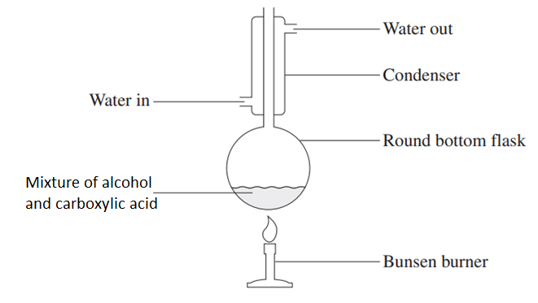

* 1. How could the apparatus shown above be modified to increase the safety of the process?

(1 mark)

* 1. Explain how and why the apparatus shown above is an improvement on the apparatus seen in the video on esters you watched in class.

(2 marks)

1. Fatty acids are long-chain carboxylic acids. The table above gives information about a selection of fatty acids. You may assume that the hydrocarbon chains of all the listed fatty acids are unbranching. Parts (a) to (d) of this question refer to the information in this table.

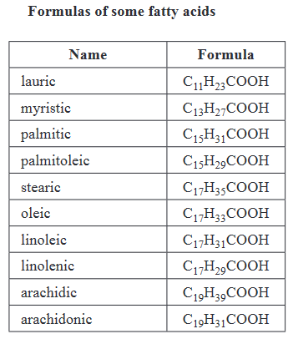

* 1. Consider myristic acid and the ester made by reacting myristic acid with methanol. Which will have the higher melting point? Give reasons to justify your choice.

(6 marks)

* 1. Lauric acid is reacted with propan-2-ol under appropriate conditions. Draw the condensed structural formula of the products.

(2 marks)

* 1. 10.0 g of stearic acid is reacted with 10.0 g of ethanol under appropriate conditions to form an ester. Determine the mass of excess reagent remaining after the reaction, assuming the reaction goes to completion. Give your final answer to the correct number of significant figures.

(5 marks)

1. On a shelf labelled ‘esters and carboxylic acids’ a chemist finds a bottle labelled ‘C5H10O2.
   1. One of the esters with the molecular formula C5H10O2 can be produced by the reaction of a 3-carbon secondary alcohol with another substance. Name the two substances that must react under appropriate conditions to produce this ester.

(2 marks)

* 1. Explain how you could experimentally determine if the substance in the bottle is an ester or a carboxylic acid. State the observation that will differentiate an ester from a carboxylic acid.

(2 marks)

1. A reaction pathway is designed for the synthesis of the compound that has the structural formula shown below.

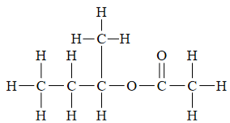

The table below gives a list of available organic reactants and reagents.

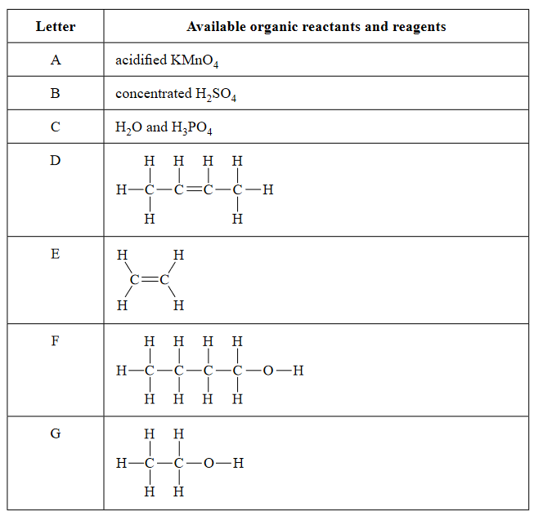

Complete the reaction pathway design flow chart on the next page. Write the corresponding letter for the structural formula of all organic reactants in each of the boxes provided. The corresponding letter for the formula of other necessary reagents should be shown in the boxes next to the arrows.

(5 marks)

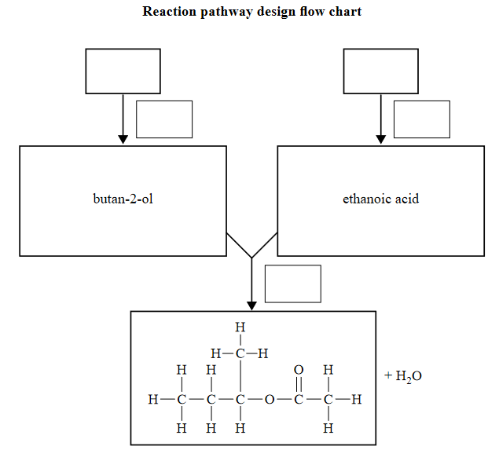

**End of Test**

**Blank Page For Rough Working. This Page Will Not Be Marked.**